**Geography Home Learning**

Here are your home learning activities for our weather topic. You can choose to do as many as you like—there is no set amount.

Your work should be beautifully presented and in your own words, you should not just copy and paste from the internet. If you think of something different to those that are listed, check with me and you could do that instead. All home learning should be brought into school on a Monday. It is optional and will earn you house point rewards.

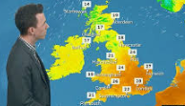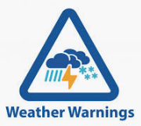 

Year 2 – Spring Term 1

**Sunrise and Sunset:** Find out what time the sun comes up and the sun sets. Write down these times for a week. Are the times always the same?

**Watch and think:** Watch a weather forecast. Think about how today’s weather will affect a farmer, a fisherman, a postman or woman and you this week.

Write and/or draw what you have found.

**Let’s get cooking:** Create a menu for a picnic for your favourite season of the year. What would you eat and where would you eat it?

**Design time:** Make a seasons picture that shows how a scene can change throughout our four seasons Spring, Summer, Autumn and Winter.

**Amazing adjectives:** Write a list of adjectives to describe different weather, e.g. hot, rainy, damp etc.

**Challenge: Poster Creator:** Find out how to stay safe in dangerous weather conditions e.g. during a lightning storm.

Draw a picture or make a poster to show people what they should or should not do.

**Observe:** Look at the clouds! Can you take a picture or draw and describe the clouds you see? With an adult’s help try and identify the clouds you have seen or we can try and find out at school.

**Puzzles:** Can you make a crossword or word search related to our topic?

**Quiz:** Create a fun quiz either on PowerPoint or in a leaflet for your friends to complete.